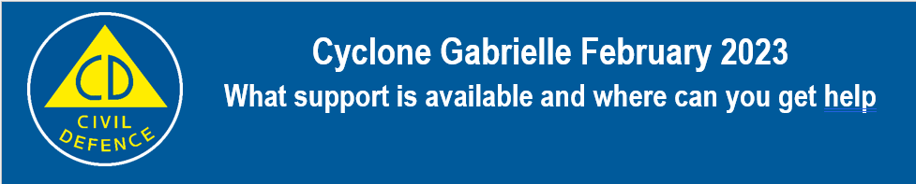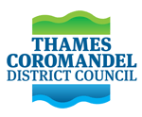

Thames-Coromandel Civil Defence Emergency Management (CDEM)
Thames-Coromandel Civil Defence Emergency Management is coordinating assistance to communities affected by Cyclone Gabrielle. Crews are out undertaking assessments of the district. Inspections to properties impacted by flood and slip damage will be carried out over the coming days.
Welfare Support
Contact ’Here to help u, 8.30am to 5pm, 7 days:
Visit www.heretohelpu.nz
or call 0800 568 273
Council services
For Council queries or issues contact Thames-Coromandel District Council 24-hours at 07 868 0200
Where to turn for help and support
When times are tough, it is normal to feel a bit worried, frustrated, or overwhelmed. We all need a little help from time to time and you don’t have to go it alone. If you or someone you know is struggling, there is free help available.
Free call or text 1737 anytime, 24 hours a day.
You can also call Lifeline on 0800 543 354 or text HELP to 4357.
Te Korowai Hauora o Hauraki Hinengaro Line for mental health support
0508 111 555

If you have health questions, phone Healthline on 0800 611 116. Healthline is staffed by experienced registered nurses 24 hours a day, 7 days a week.

Ministry of Social Development support
Support and assistance may be available if you've been affected by Cyclone Gabrielle. There are lots of ways we can help, and we can point you in the right direction based on your situation. You don't have to be on a benefit. You may have to pay the money back depending on your situation.
We’re open 7am–5pm Monday to Friday, 8am-5pm Saturday, and 8am-1pm Sunday.
Call us on 0800 400 100

Insurance and lodging a claim
If your home, car, or contents have been damaged by the severe weather, take photos before you remove or repair anything and report it to your insurance company as soon as possible. You only need to contact your insurance company and they’ll let you know what you need to do next, how to claim and – if applicable – how EQC cover works.
If you need to make your home safe, sanitary, secure, and weather tight, please record the work done, take before and after photos, and keep copies of the bills you paid.
If you don't have house insurance but do have contents insurance, speak to your insurer about what is covered. Make sure you take lots of photos and keep good records before you throw anything out, where possible.
The Residential Advisory Service (RAS) within MBIE provide advocacy services and advice to homeowners who are navigating insurance claims to remediate damage suffered due to an event. info@advisory.org.nz 0800 777 299
Tenancy information
If you are the tenant or landlord of a rental property, you can find information on your rights and obligations at www.tenancy.govt.nz or by phoning 0800 TENANCY (0800 836 262).
Support for rural communities
Rural Support Trusts have local people who are trained to offer assistance and support, and their help is free and confidential. Phone 0800 RURAL HELP (0800 787 254) or visit www.rural-support.org.nz.

