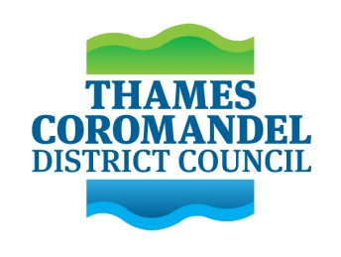 | Agenda
Thames Protection & Resilience
Governance Group

Time & Date: | 10:30am – 12:30pm 20/02/2024
Venue: | TCDC Emergency Management Room, 515 MacKay Street Thames & MS Teams
Chairperson:  Attendees: | Len Salt – Mayor, TCDC  Ngati Maru representatives – Craig Solomon, Wati Ngamane  WRC representatives – Warren Maher, Katarina Hodge  (or alternates)  TCDC representatives – Robyn Sinclair, Deli Connell, Terry Walker (or alternates). Martin Rodley (alternate), Peter Revell (alternate).  Project Office – TCDC staff Amon Martin, Jamie Boyle, Karen Moffatt-McLeod, Mitchell King, Leslie Vyfhuis, Connie Buchanan  WRC staff - Alejandro Cifuentes, Dawn Pritchard  SMP Consultants - Sian John (Royal HaskoningDHV), Shari Gallop, PDP
Agenda Items
- Karakia timatanga
- Introduction
- Background:
- Shoreline Management Plan – Thames Pathway and Protection Concept
- Thames and Surrounds Spatial Planning overview
- Terms of Reference
- Programme
- Stakeholder Mapping & Protection Design Principles
- Next steps
- Closing remarks
- Karakia whakamutunga

Supporting Documents:
- PU2 - Thames Coastal Adaptation Plan (CAP)
- Thames and Surrounds Spatial Plan (October 2022)
- Governance Group Draft Terms of Reference (February 2024)
- Project Plan – Year 1 – Rev 5
- Stakeholder mapping context

