BIOSOLIDS MANAGEMENT
EASTERN SEABOARD
LOCAL IN-VESSEL COMPOSTING PLANTS

Project Business Case

Prepared By: Water Engineering Consultants Ltd for Viv Eyberg (Capex Programme Manager)

Date: September 2007

Index

1 Executive Summary

2 Project Objectives

3 Project Benefits

4 Strategic Fit

5 Project Scope

6 Project Assumptions

7 Consultation

8 Options

9 Preferred Option, including:
9.1 Risk assessment
9.2 Strengths and Weaknesses
9.3 Cost benefit analysis

10 Capabilities and Constraints

11 Implementation

1. Executive Summary

  - Introduction

Council’s programme to upgrade the Eastern Seaboard Wastewater Treatment Plants (ESB WWTPs) is progressing well. These upgraded WWTPs will produce biosolids that need disposal on a regular basis, compared to the existing Oxidation Ponds. Council’s Biosolids Management Strategy (BMS), adopted in May 2006, aims to address how the sludge produced from the upgraded plants should be beneficially used, instead of sending it to landfills. In addition to it being an unsustainable option, Council believes that landfilling costs will spiral upwards.

The Eastern Seaboard Biosolids Compost Project (ESBCP) proposes to install three in-vessel composting plants and construct the required ancillary works at Tairua-Pauanui, Whangamata and Whitianga.

The design-build-operate contract for the wastewater treatment plant upgrades at the three sites (Whangamata, Whitianga and Pauanui) was awarded in August 2006 and the new WWTP at Pauanui is nearing completion. The WWTP construction works at Whangamata and Whitianga are also progressing well. Therefore, the time is right to construct the composting plants that will put to beneficial use the biosolids generated by the upgraded WWTPs.

The proposed in-vessel composting plants are vital components of the Council’s BMS. This Business Case describes the proposed works, associated costs and benefits relating to the three in-vessel composting plants.

  - Case for Investment

The Council has a responsibility to provide the necessary infrastructure and services to its communities while also protecting the environment from adverse effects and meeting consenting requirements.

The primary benefit of the ESBCP is the sustainable management and environmentally beneficial use of the biosolids generated by the three communities of Tairua-Pauanui, Whangamata and Whitianga.

A secondary benefit will be a long-term financial saving in the sludge disposal cost. It is estimated that the lifecycle cost of in-vessel composting of biosolids will be in the range $900 to $1,100 per dry tonne of sludge. The current cost of landfilling is in the range $1,100 to $1,400 per dry tonne of sludge. As the available landfill volumes diminish and the environmental controls become more stringent, the landfilling cost is very likely to spiral much higher than the current range of $1,100 to $1,400 per dry tonne of sludge. Therefore, there will be substantial savings to the ratepayers, in the long-term, if the Council succeeds in composting biosolids.

The above-mentioned financial benefit does not include potential income from the possible sale of some of the compost products. Income from any sales of compost will be a bonus financial benefit, in addition to the basic financial benefit of saving in the landfilling cost.

Another important benefit, which is not inferior to any of the above, is the enhanced Council image as an eco-friendly authority, leading by example to find sustainable solutions and minimise waste.

  - Project Scope

We are proposing to compost the biosolids produced by the upgraded WWTPs using local in-vessel composting plants, located at Tairua, Whangamata and Whitianga.

One advantage of the in-vessel composting systems is that they are modular. It is proposed to install a mix of 600t/yr and 1,000t/yr modules at the three locations, depending on the actual monitored sludge production and the greenwaste requirement. The in-vessel plants installation is proposed to be staged as indicated in Table E1 below:

Table E1: Proposed Staging of the ESBCP
Location | Total Installed Capacity – Tonnes per Year
Location | Stage 1 | Stage 2 | Stage 3
Tairua-Pauanui | 600 | 1,200 | 2,200
Whangamata |  | 1,000 | 3,000
Whitianga |  | 1,000 | 3,000

It is proposed to implement Stage 1, i.e. 600t/yr in-vessel plant at Tairua-Pauanui in this financial year 2007 / 08. Tairua refuse transfer station site is proposed for in-vessel composting at Tairua-Pauanui.

For the first 4 months the Tairua plant will function as an in-vessel composting trial to establish the best operating procedures, as per Biosolids Guidelines and NZS4454 Compost Standard. We have received an attractive offer from NexGen Limited, manufacturers of Rotocom in-vessel composting system, to partner a composting trial for four months in this summer (07/08).

  - Funding
Provision for funding has been made in the 2007/08 Annual Plan, the 2006/16 LTCCP, and the Wastewater Asset Management Plan.

2007/2008 Tairua trial and permanent plant $992,000

2008/2010 Whangamata and Whitianga permanent plants $2,134,000

2. Project Objectives

The main objective of the proposed works is to beneficially use the biosolids that will be produced by the three upgraded Wastewater Treatment Plants of the Eastern Seaboard, at Tairua-Pauanui, Whangamata and Whitianga.

Council’s programme to upgrade the Eastern Seaboard Wastewater Treatment Plants (ESB WWTPs) is progressing well. These upgraded WWTPs will produce biosolids that need disposal on a regular basis, compared to the existing Oxidation Ponds. Council’s Biosolids Management Strategy (BMS) aims to address how the sludge produced from the upgraded plants should be beneficially used, instead of sending it to landfills. In addition to it being an unsustainable option, TCDC believe that landfilling costs will spiral upwards.

In order to ensure the sustainability of wastewater management in the peninsula, Council’s BMS includes, among others, the following principal objectives:

- Producing Grade “A” biosolids at the upgraded WWTPs
- Composting biosolids blended with green waste, at local in-vessel composting plants to produce Grade “Aa” compost
- Unrestricted use / sale of Grade “Aa” compost

The design-build-operate contract for the plant upgrades at the three sites (Whangamata, Whitianga and Pauanui) was awarded in August 2006 and the new WWTP at Pauanui is nearing completion. The WWTP construction works at Whangamata and Whitianga are also progressing well. Therefore, the time is right to construct the composting plants that will put to beneficial use the biosolids generated by the upgraded WWTPs.

This Business Case describes the proposed works, associated costs and benefits relating to the three in-vessel composting plants.

3. Project Benefits

The primary benefit of the Eastern Seaboard Biosolids Compost Project (ESBCP) is the sustainable management and environmentally beneficial use of the biosolids generated by the three communities of Tairua-Pauanui, Whangamata and Whitianga.

A secondary benefit will be a long-term financial saving in the sludge disposal cost. It is estimated that the lifecycle cost of in-vessel composting of biosolids will be in the range $900 to $1,100 per dry tonne of sludge. The current cost of landfilling is in the range $1,100 to $1,400 per dry tonne of sludge. We are in the process of desludging the Thames Retention Pond and the dewatered sludge is being landfilled. We are fortunate to have been offered an unusually competitive price for this work, at approximately $1,100 per dry tonne of sludge, including dredging and dewatering cost. It is highly unlikely that a similar price will be available in the future. As the available landfill volumes diminish and the environmental controls become more stringent, the landfilling cost is very likely to spiral much higher than the current range of $1,100 to $1,400 per dry tonne of sludge. Therefore, there will be substantial savings to the ratepayers, in the long-term, if the Council succeeds in composting biosolids.

The above-mentioned financial benefit does not include potential income from the possible sale of some of the compost products. Initially, we are proposing to use the biosolids compost in the Council parks and reserves. This, alone with our on-going community education programmes, will invariably lead to increased public awareness of the potential benefits of biosolids compost, both in terms of direct benefits to horticulture and agriculture and environmental benefits of a sustainable solution for biosolids management. Thames-Coromandel public will want to both benefit by the compost use and contribute to the environmental solution. We, therefore, expect that in a few years time, a significant portion of the biosolids compost will be able to be sold at market prices. This will be a bonus financial benefit, in addition to the basic financial benefit of saving in the landfilling cost discussed in the preceding paragraph.

Another important benefit, which is not inferior to any of the above, is the enhanced Council image as an eco-friendly authority, leading by example to find sustainable solutions and minimise waste.

4. Strategic Fit

There are key strategic planning processes and outcomes that provide guidance when planning and identifying infrastructure requirements. A summary of how the proposed in-vessel compost plants at the Eastern Seaboard fit into Council’s strategic programme is provided below.

Community Outcomes
The TCDC Long Term Council Community Plan (LTCCP) 2006-2016) identified seven key community outcomes. The Eastern Seaboard Biosolids Compost Project (ESBCP) fits with three outcomes in particular (pg. 40 & 41):

- “Our communities recognise and value the natural environment” – By implementing a sustainable solution for biosolids management, we enhance and protect the natural environment
- “The needs of both local and visitor communities are met though sound planning, ahead of growth and development” – We have planned the composting solutions to meet the future growth of the Eastern Seaboard
- “We reduce, reuse and recycle waste” – By preventing the sludge from going to landfills, we are reducing, reusing and recycling waste; in fact, we are preventing a valuable resource from being wasted
- “We have quality infrastructure and services” – The compost plants will be leading edge, eco-friendly technology
- “We have efficient and effective water and waste services” – We will maximise the efficiency of our wastewater services by dealing with all its products in a sustainable manner
- “Our parks and reserves are maintained and developed to meet future growth” – The biosolids compost will help maintain the parks and reserves, and enhance their amenity values
- “Our communities are prepared for emergencies” – By installing three local compost plants, as against a one larger central compost plant, we are better prepared for emergencies

Council Strategic Fit:
The 2006-2016 LTCCP (p18) identifies six key strategic programmes within which Council will work over the next three to five years. These key strategic programmes fit well with and support the Eastern Seaboard Biosolids Compost Project (ESBCP).

- “Planning for the Future” – The ESBCP plans for the future sustainable management of biosolids and significant financial benefits to the communities by way of saving landfilling costs
- “Community Engagement” – The ESBCP expects to engage the community by using biosolids compost to support this environmentally sustainable solution
- “Promoting the Development of Our Communities” – The ESBCP will promote the development of the eastern seaboard communities by providing them with a fully complying and complete wastewater system
- “Infrastructure Development and Maintenance” – The ESBCP will use the best available technology and standards for developing these components of the eastern seaboard wastewater infrastructure, and to make them maintenance friendly
- “Safeguarding our environment” – The primary objective of the ESBCP is safeguarding our environment
- “Organisational development” – We will undertake the necessary organisational development within the Council to meet the long-term needs of the ESBCP

Wastewater Activity
The 2006-2016 LTCCP and the Annual Plan 2007-08 have allocated $3 million for biosolids management infrastructure for Tairua-Pauanui, Whangamata and Whitianga, for the next three to four years. Tairua-Pauanui biosolids infrastructure will be trialled in 2007-08, before the other plants. This biosolids management infrastructure will consist of in-vessel composting plants and ancillary works.

Whitianga Community Plan
The Vision Whitianga Community Plan, prepared by the local community identifies ‘community outcomes’ for the Whitianga Township based on the four well beings economic, environmental, social and cultural. The following three environmental outcomes listed under “what we want” are all relevant to the ESBCP:

Waste Management (p20):
- “A community that embraces the concept of Re-use, Recycle and Reduce” - By preventing the sludge from going to landfills, we are reducing, reusing and recycling waste; in fact, we are preventing a valuable resource from being wasted
- “A Council in partnership with others, committed to ongoing education and training programmes to achieve this” – We propose to implement the ESBCP in partnership with specialist compost producers who will train the local operators to make high quality compost

Wastewater (p14)
- “A quality well maintained treatment and disposal system that is capable of meeting the demands of residential and industrial needs” – In-vessel biosolids composting is a sustainable, high quality disposal system best suited for the District

Whangamata Community Plan
Whangamata Community Plan, Our Future, prepared by the local community declares Whangamata as “An Eco-Town” (p3), which is:

- “Environmentally sustainable” – Beneficial use of biosolids, as proposed in the ESBCP, is the only sustainable way of managing biosolids
- “Economically viable” – The ESBCP is economically viable, projected to save significantly cost of sludge landfilling
- “Socially responsible” – The ESBCP will be socially responsible by ensuring high level of quality control and accurate labelling of products

Whangamata Community Plan proposes (p8) that “the water strategy and best practice guidelines must be guided by the three principles of an eco system approach; Integration; Zero waste; and Based on the natural water cycle”. The ESBCP fits in well with these principles aiming to minimise waste and follow the natural cycle of resources from and back to earth.

Pauanui Community Plan
Pauanui Community Plan, Vision Pauanui, prepared by the local community, proposes (p24) for the wastewater infrastructure the outcome of “a reliable network of services supporting our fluctuating population while protecting and enhancing our unique environment”. The Eastern Seaboard Biosolids Compost Project (ESBCP) is the only environmentally sustainable solution best suited for the area for managing biosolids. By the very nature of composting operations, it can absorb fluctuations in biosolids loading.

Tairua Community Plan
Tairua Community Plan, Your Future, Your Choice, Your Community, prepared by the local community, in the discussion on Development, Growth, Environment and Infrastructure, states that “435 (98%) of 442 people answering a question on maintaining environmental integrity during the period of upcoming growth believe that this is important or extremely important. Most people believe that environmental protection overrides the economic advantages of development”. The ESBCP protects the environment by sustainably managing the biosolids generated by the community, and an important benefit of ESBCP is that it will not need to override the economic advantages of development. The project will be financially beneficial too, by saving landfilling costs.

As outcomes, the plan proposes, “Tairua - a seaside village in an attractive natural setting, with growth managed in a way that does not compromise its special qualities. A community with quality infrastructure that will sustain an increased temporary and permanent population”. In-vessel composting plants will be leading edge technology, quality infrastructure, that will be designed to meet the fluctuating biosolids loading of the area.

Wastewater Asset Management Plan
The Wastewater Asset Management Plan provides detailed planning for wastewater in the district and has allocated $3 million, in its LTCCP Adopted Capital Works Programme, for biosolids infrastructure for Whitianga, Tairua-Pauanui and Whangamata, within which the ESBCP fits. In Section 12 of the AMP giving scheme strategies for the three communities, the plan has assigned to the ESBCP “Very Important” for the consequence grading and “High” for the priority grading.

TCDC Biosolids Management Strategy (BMS)
This Council document was adopted in May 2006 following two stages of community consultation. One of the principle components of the BMS is stated below and relates directly to the Eastern Seaboard Biosolids Compost Project (ESBCP):

“The BMS will consist of, among others, the following principal component: Composting biosolids blended with green waste, at local in-vessel composting plants to produce Grade “Aa” compost”.

Regional Council Policy
The above discussion amply demonstrates that the ESBCP fits well with the Council strategy and the Community expectations. It also agrees with the Environment Waikato (EW) policies.

Environment Waikato Policy 3.9.5 promotes; “reusing waste items, recycling waste materials by reprocessing and using them as raw material for other products, and recovering resources from waste”. The ESBCP’s primary objective is to sustainably use biosolids in a beneficial manner, a resource which otherwise will, not only go to waste, also take up limited space in landfills.

With regard to biosolids compost, EW require conforming to the more stringent 2012 Grade "a" contaminant limits given in the Biosolids Guidelines (NZWWA, 2003), and land application of Grade Aa biosolids compost will require EW resource consents. These requirements agree with the ESBCP’s intention to produce Grade Aa biosolids compost to 2012 limits.

Central Government Policy
The ESBCP is consistent with the central government policy. One objective in the New Zealand Waste Strategy, published by Ministry for Environment in 2002, is by “December 2007, more than 95% of sewage sludge currently disposed to landfill will be composted, beneficially used or appropriately treated to minimise the production of methane and leachate”. The MfE strategy also set targets for waste minimisation and improved trade waste management, and recognises that the “beneficial use of biosolids provides an incentive for improved trade waste management”.

5. Project Scope

5.1 Introduction:

The Eastern Seaboard Biosolids Compost Project (ESBCP) proposes to install three in-vessel composting plants and construct the required ancillary works at Tairua-Pauanui, Whangamata and Whitianga.

5.2 Existing System:

At present, the three eastern seaboard communities are serviced by oxidation ponds, which accumulate sludge over a long period of time. The ponds are normally desludged at 10 to 15 years intervals. Driven by the requirements for better effluent quality, Council is currently replacing the oxidation ponds with modern Wastewater Treatment Plants (WWTPs).

These upgraded WWTPs will produce biosolids that will need to be disposed of at short intervals.

5.3 Proposed System:

We are proposing to compost the biosolids produced by the upgraded WWTPs using local in-vessel composting plants, located at Tairua, Whangamata and Whitianga. The estimated quantities of compost production are shown in Tables 1 and 2 below:

Table 1: Projected Annual Compost Production by 2010 – Tonnes per Year Wet Weight
Parameter | Whitianga | Tairua-Pauanui | Whangamata
Estimated sludge production | 800 | 700 | 800
Required greenwaste quantity | 1350 | 1200 | 1350
Compost plant input | 2150 | 1900 | 2150

Table 2: Projected Annual Compost Production by 2026 – Tonnes per Year Wet Weight
Parameter | Whitianga | Tairua-Pauanui | Whangamata
Estimated sludge production | 1100 | 800 | 1000
Required greenwaste quantity | 1900 | 1400 | 1700
Compost plant input | 3000 | 2200 | 2700

One advantage of the in-vessel composting systems is that they are modular. It is proposed to install a mix of 600t/yr and 1,000t/yr modules at the three locations, depending on the actual monitored sludge production and the greenwaste requirement. The in-vessel plants installation is proposed to be staged as indicated in Table 3 below:

Table 3: Proposed Staging of the ESBCP
Location | Total Installed Capacity – Tonnes per Year
Location | Stage 1 | Stage 2 | Stage 3
Tairua-Pauanui | 600 | 1,200 | 2,200
Whangamata |  | 1,000 | 3,000
Whitianga |  | 1,000 | 3,000

This staged approach and modular build-up will allow us to match the installed capacity to the actual requirements, as this leading edge, new technology is adapted to the local conditions. In between stages, it will be necessary to landfill some of the sludge that will be in excess of the installed capacity.

It is proposed to implement Stage 1, i.e. 600t/yr in-vessel plant at Tairua-Pauanui in this financial year 2007 / 08. Tairua refuse transfer station site is proposed for in-vessel composting at Tairua-Pauanui.

In-vessel composting systems include VCU, a vertical in-vessel system and, HotRot and Rotocom, which are horizontal in-vessel systems. The lifecycle costs of the three systems are similar. The VCU is not a suitable vessel for composting biosolids as the compost is moved through the vessel utilising gravity with no mixing taking place, cold spots develop and pathogens are not eliminated. Rotocom technology has an advantage, as it is the drum that is rotating to ensure proper mixing within the vessel, compared to the central shaft auger rotating in other technologies. This avoids significant quantities of material sticking to the vessel’s interior surface. This technology reduces the risk of producing non-complying compost. Rotocom and HotRot responded to a registration of interest. Rotocom have also responded to a request from us for a proposal for a partnership arrangement for this trial. They have offered us a on off deal to supply us with a 600t/yr plant at a greatly reduced cost. We are currently in discussion to arrange that they will sell the used plant for us should the trial not be successful.

5.4 In-Vessel Composting Process:

The process requirements of an in-vessel composting system is summarised below:

5.4.1 Pre-Composting

Shredding / chipping: Variable particle sizes of greenwaste will be added to biosolids to lower the contaminant concentrations and help create an aerated compost mixture. Typical particle sizes range from 12mm to 40mm, and the greenwaste must be shredded / chipped for this purpose. It is proposed to hire the services of a shredder on a long-term basis, which will go to each site, as the greenwaste is stockpiled.

Mixing: is required to create a uniform & homogenous mix of the biosolids & greenwaste, prior to inputting into the vessel. A small front-loader will be hired on a long-term basis for this purpose. Biosolids will be stored in the WWTP temporarily and delivered to the composting site on a regular basis (e.g. weekly) only when the composter is ready for accepting a batch of biosolids-greenwaste mix. Biosolids received at the site will be mixed immediately with greenwaste and fed into the composter. Rotocom units have a mixer / feed system to further mix the input material.

5.4.2 During Composting

Turning: As mentioned before, the vessel’s outer drum will turn the material as it passes through the vessel. This helps to introduce air into the mix and maintain consistent temperature gradients throughout the material mass.

Temperature: within the composting mass will rise due to biological activity. Temperature profiles within the vessel will be monitored to ensure required time-temperatures are achieved. Monitoring and controlling aeration and moisture within the mix is automated.

Odour management: is carried out by temperature and aeration control. Vapours are withdrawn and processed through a biofilter.

Leachate management: is carried by moisture control. Any excess moisture from the vessel will be collected and disposed back to the WWTP.

5.4.2 Post-Composting

Maturing: of the compost exiting from the vessel will be carried out in a sheltered outdoor area to stockpile and mature the compost for approximately 5 weeks. These stockpiles will be roofed over or covered to manage odour and leachate.

Screening: of matured compost will be carried out in the above-mentioned stockpile area, and we propose to hire a portable trommel screen on a long-term basis, which will visit each compost site regularly. It will screen compost to a particle-size as specified in Table 3.1 of NZ Compost Standards (e.g. not more than 5% retained by 20mm sieve).

5.5 Site Management Plans:

For each of the three composting sites, we will prepare, keep up to date, and implement Site Management Plans, which will include best practice guidelines for the following, based on New Zealand Biosolids Guidelines, New Zealand Standards for Composting and OSH requirements:

- Odour Management
- Leachate Management
- Health and Safety
- Compost Quality Assurance
- Customer Relations
- Traffic Management
- Public Access Management
- Compost Delivery Management

Council will obtain the EW approval for the Site Management Plans, prior to commencing composting operations.

5.6 Compost Quality Assurance:

As we mentioned before, Council’s objective is to produce Grade Aa compost, conforming 2012 contaminant limits of the Biosolids Guidelines. There are detailed guidelines on the compost quality assurance in the New Zealand Compost Standards (NZS4454) and the Biosolids Guidelines (NZWWA, 2003). A comprehensive independent sampling and testing regime will be set up in accordance with the Guidelines.

The compost quality will be controlled by producing better quality biosolids at the WWTPs, and adjusting biosolids – greenwaste mix proportions, residence time and vessel rotating speed. The quality control requirements include the following:

- Heavy metal and organic contaminant concentrations should be below the 2012 Grade “a” limits set out in Tables 7.1 and 7.2 of Volume 2 of Biosolids Guidelines

- In-vessel temperature of > 55 degrees Celsius for > 3 days (the temperature rise will be through natural biological activity; the quality assurance procedure will monitor the temperature to ensure and log that the requirement has been fulfilled)

- Mass of volatile solids in compost should be reduced by a minimum of 38%; or in-vessel temperature > 40 degrees Celsius for > 14 days with the average temperature > 45 degrees Celsius

The quality verification testing of the compost products that exit the vessel will include the following:

- Testing for heavy metal and organic contaminant concentrations to verify that these are below the 2012 limits

- Testing for pathogens to verify E coli < 100MPN/g; Campylobacter < 1/25g; Salmonella < 1/25g; Enteric viruses < 1PFU/4g; Helminth ova < 1/4g; and Cryptosporidium Giardia < 1/50g

Initially, one composite sample will be tested weekly. As the process and the quality are established, the number of tests will be reduced, with EW approval.

5.7 Proposed Tairua-Pauanui Biosolids Composting Trial – 2007/08:

We have received an attractive offer from NexGen Limited, manufacturers of Rotocom in-vessel composting system, to partner a composting trial for four months in this summer (07/08). The offer includes the following:

- A complete Rotocom system including RC42 vessel, mixer/feed unit and integrated electrical control system (capacity 600t/yr)

- Installation, commissioning, training plant operators, and consultancy services for the duration of the trials

- Responsibility for demonstrating the Rotocom system meets the pathogen reduction and vector attraction reduction requirements of the Biosolids Guidelines

- Joint promotion of the trial in partnership with TCDC

The NexGen offer is priced at NZ$325,000, which is very reasonable compared to prevailing in-vessel composter prices. The plant capacity matches the staged approach given in Table 3, and upon successful completion of the trial, the Rotocom plant will become a permanent component of the Eastern Seaboard Biosolids Compost Project (ESBCP). We are currently negotiating an on sell agreement with NexGen, to cover the unlikely event of the trial being unsuccessful. It is estimated that the maximum loss on the Rotocom (if on sold) would be $50,000.

As our contribution to the partnership, we are required to provide ancillary site works, biosolids from the new Tairua-Pauanui WWTP, shredded greenwaste, pre-mixing, compost product screening, quality testing and operating labour. It is proposed to locate the Rotocom plant on the existing unused concrete plinth at Tairua Refuse Transfer Station (refer Figure 1). The services such as shredding and mixing will be hired as discussed in Section 5.4 above.

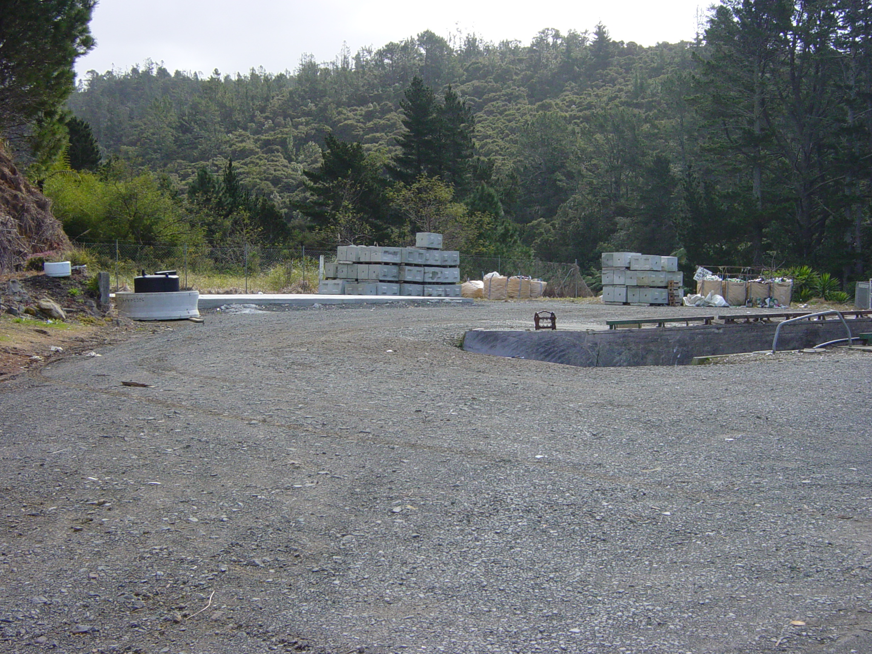
Figure 1: Proposed Trial Location at Tairua Refuse Transfer Station
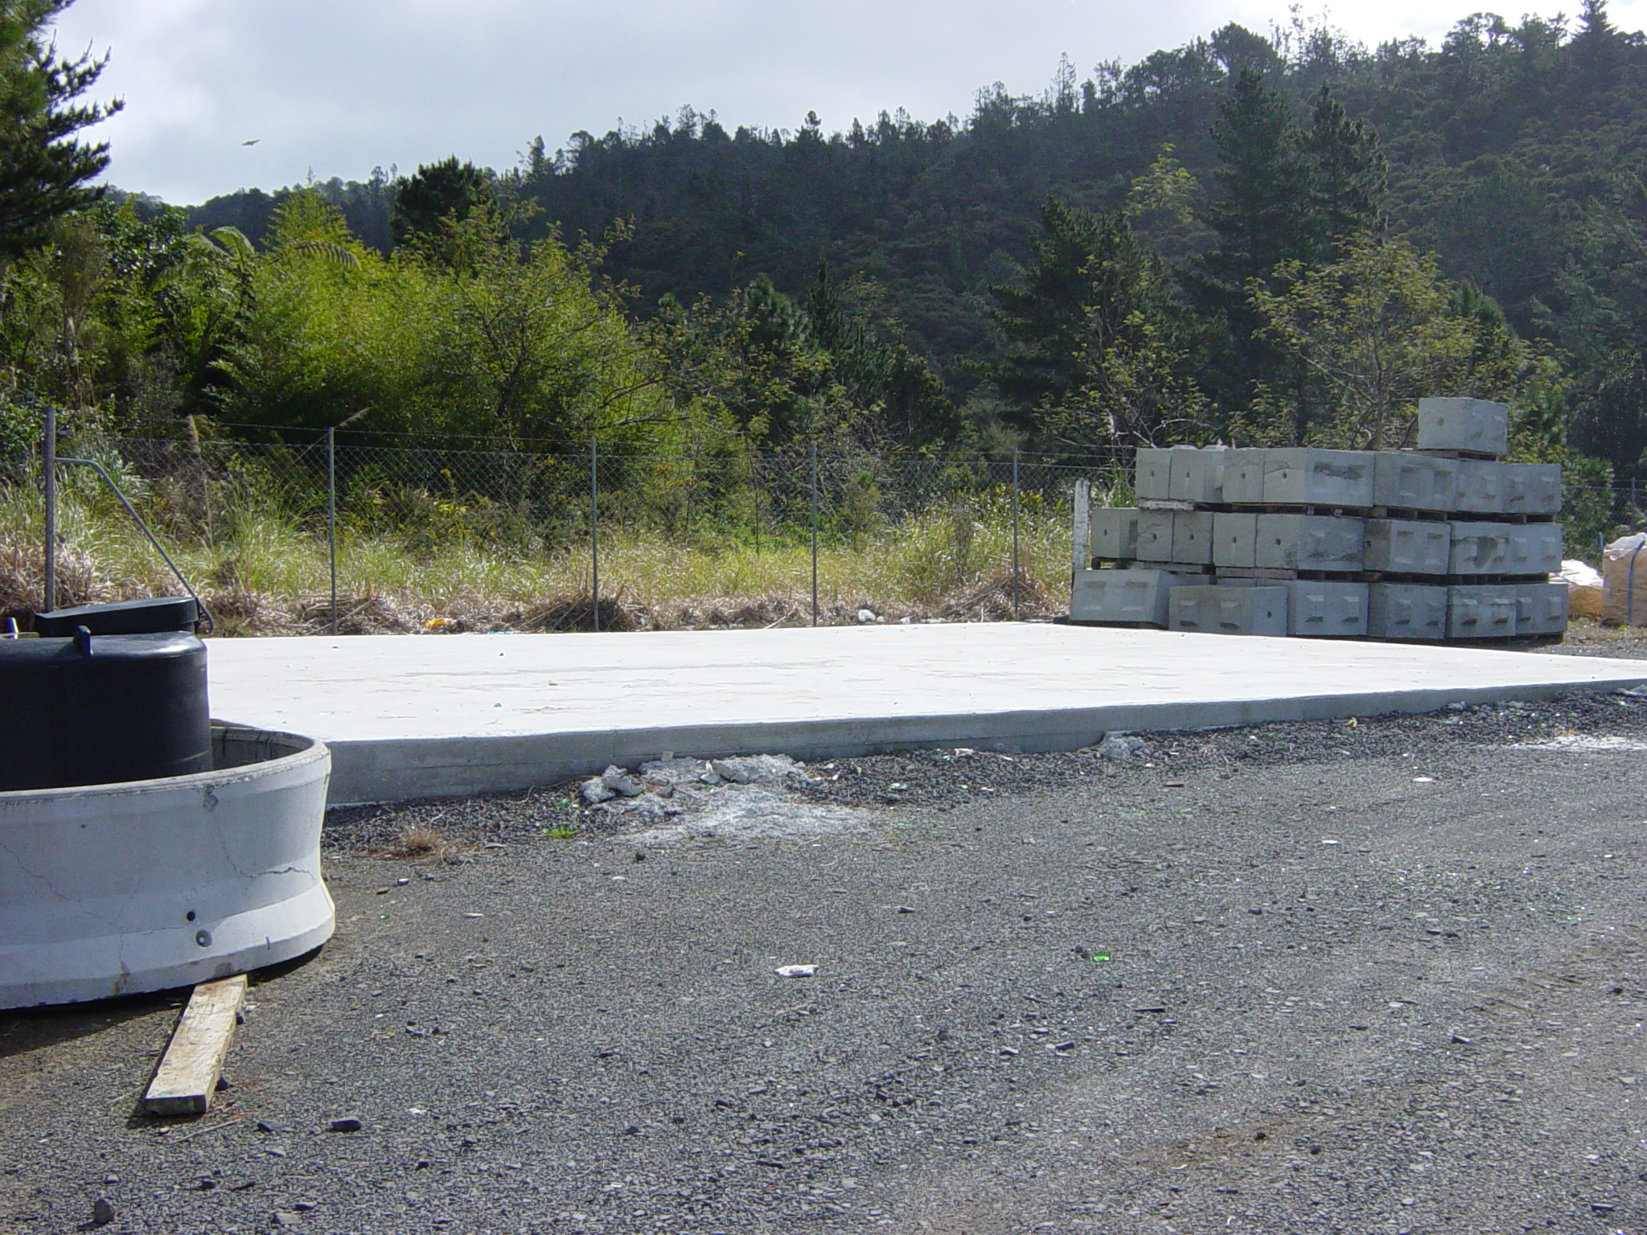

The estimated trial cost is (note still being negotiated) $50,000 for labour, $50,000 for set up (includes a shed that could be used at another site if trial unsuccessful) and a contingency of $6,000 for landfilling out of specification compost.

It is recommended to accept the NexGen offer, subject to EW approval of the trial, and granting TCDC consent to proceed with the trial.

We are in the process of consulting the Ministry for the Environment (MfE) with a view to apply for a part funding of the Tairua Composting Trial by the Sustainable Management Fund (SMF).

5.8 Eastern Seaboard Greenwaste Quantities and Quality:

We collect sufficient greenwaste quantities at the eastern seaboard refuse transfer stations, to feed the proposed compost plants. In February 2007, Water Engineering Consultants Limited (WEC) prepared a report summarising the results of investigations and testing carried out to assess the quantities and quality of greenwaste collected by four eastern seaboard transfer stations.

Heavy metal and organic compound concentrations found in the eight samples of the greenwaste collected from the four transfer stations in December 2006 and February 2007 meet the NZWWA Grade ‘a’ guideline limits, with the one exception of arsenic in the Whitianga samples which remained slightly elevated (average 26mg/kg, compared to guideline level of 20mg/kg). Such limited quantities of exceptionally bad quality greenwaste will need to be excluded from the composting process.

Using average concentrations of copper and zinc expected to be contained in biosolids produced from each upgraded WWTPs together with the average concentrations found in the tested greenwaste samples, it is estimated there will be sufficient greenwaste quantities available locally, in the eastern seaboard, to provide the necessary dilution to produce a compost product that can meet the NZWWA Grade ‘a’ guideline limits. The estimated greenwaste requirement and the current collection quantities are given in Table 4 below:

Table 4: Available and Required Greenwaste Quantities – Cubic Metres per Month
Community | Quantity of greenwaste required to mix with biosolids, using copper/zinc greenwaste sampling results | Reported greenwaste handled at Council transfer stations at present
Whitianga | 152 | 180
Pauanui/Tairua | 136 | 245
Whangamata | 162 | 225
Total | 450 | 650

Concentrations of zinc in the greenwaste samples were the most variable of all the heavy metals (ranging from 65 to 261ppm) and this variability will influence the quantities of greenwaste required for dilution purposes.

5.8 Resource Consents:

We have initiated consultation with EW to clarify the necessary consenting requirements for the proposed 2007/08 biosolids composting trial at Tairua refuse transfer station, using biosolids from the soon-to-be-completed Tairua-Pauanui WWTP. We view this trial as a data gathering exercise for the resource consent applications for the permanent in-vessel composting plants.

The initial EW feedback is encouraging, in that they have no objection in principle to biosolids composting. However, EW are requiring a resource consent for the trial, their major concern being odour management. EW have indicated that the application will be assessed on a non-notified basis.

Rotocom plant offered by NexGen includes in-vessel odour control processes. With the best practice site management plan discussed in Section 5.5, we are confident of mitigating any odour issues to the satisfaction of EW.

6. Project Assumptions

There are two principle project assumptions.

Firstly, it has been assumed that the applications to Environment Waikato (EW) relating to the 2007 / 08 trial at Tairua and the permanent installations at Tairua, Whangamata and Whitianga will be approved. Further, it is assumed that even if some approvals are delayed, it will be easier for EW to grant a quick approval for the 2007 / 08 trial for the following reasons:

- Any potential effects are smaller

- The trial will provide information for formulating consent conditions for the biosolids composting in Eastern Seaboard, and more importantly, in the entire District

7. Consultation

It is considered that no specific consultation is required with respect to biosolids composting, because these are activities related to greenwaste treatment and will be carried out within the refuse transfer station areas.

However, with respect to biosolids composting and beneficial-use of biosolids, community consultation has been undertaken as part of the development of the TCDC Biosolids Management Strategy (BMS) for the whole District. Consultation for the BMS included two stages, as follows:

- January/February 2006: Community and industry consultation (CIC) was undertaken, which was essentially a virtual workshop, carried out through an Interactive Web Page on the TCDC Web Site and via newspaper advertising. Interested parties were able to obtain information about and provide feedback on a long-list of proposed options on how to deal with sewage sludge from the various WWTPs throughout the District.

- February/March 2006: Comprehensive stakeholder consultation was undertaken, which involved posting a brochure containing 4 short-listed options on the TCDC web-page as well as sending brochure to specific groups and interested parties (i.e. ratepayer associations, clean water groups, and people who have expressed interest/responded to the web-page).

8. Options

We have considered various options regarding the disposal / beneficial-use of biosolids generated by the upgraded WWTPs at Whitianga, Tairua-Pauanui and Whangamata. The main options are summarised in Table 5 below. It is noted that ‘Doing Nothing’ is not an option, as the biosolids must be managed by some means.

Table 5: Biosolids Management Options
Option |  | Issues and Solutions
1 | Constructing a sludge holding pond within the decommissioned ponds | 1.1 | This is not a sustainable solution. What do we do with future sludge?
 |  | 1.2 | Odour issues will be practically unmanageable.
 |  | 1.3 | Resource consents will not be granted.
2 | Monofill on decommissioned pond site | 2.1 | This is not a sustainable solution. What do we do with future sludge?
 | Monofill on decommissioned pond site | 2.2 | Leachate must be managed by collecting the leachate and recycling to the WWTP
 | Monofill on decommissioned pond site | 2.3 | Potential for groundwater and surface water contamination must be managed
 | Monofill on decommissioned pond site | 2.4 | Odour must be managed by daily covering deposited sludge
 |  | 2.5 | Vector attraction must be reduced by daily covering deposited sludge
 |  | 2.6 | Bird attraction must be reduced by daily covering deposited sludge
 |  | 2.7 | Unlikely to get resource consents
3 | Biobags on decommissioned pond sites | 3.1 | This has similar issues as the monofill option, and also costs more
 |  | 3.2 | Requires a larger area of land than for a monofill
 |  | 3.3 | Long-term maintenance issues
4 | Disposal to an external landfill | 4.1 | This is not a sustainable solution, and against the principles of TCDC, EW and the government
 |  | 4.2 | High cost
 |  | 4.3 | Transport of untreated sludge must be managed by using purpose built trucks
 |  | 4.4 | Increased traffic loads
5 | Local in-vessel composting  This is the recommended option | 5.1 | Contaminant concentrations will be reduced by diluting with green waste
 | Local in-vessel composting  This is the recommended option | 5.2 | Potential for groundwater and surface water contamination is low
 | Local in-vessel composting  This is the recommended option | 5.3 | Odour management is easier
 |  | 5.4 | Vector attraction is reduced by composting
 |  | 5.5 | Bird attraction will be reduced by covering the product

9. Preferred Option

The preferred option has been described in Section 5: Project Scope.

It is proposed to implement the 2007/08 trial through three contracts. The first contract will be with NexGen for a partnering arrangement to supply and commission the vessel and train the operators. It is proposed to award this contract on a negotiated basis as this is a specialist service, bidders are limited, a number of enquiries to in-vessel composting plant manufacturers resulted in receiving only this one offer, and finally, the offer is considered very reasonable, compared to prevailing prices of in-vessel plants. Council’s approval to negotiate with Nexgen is required as provided in the Procurement Policy.

The second contract will be for ancillary site works, which will be a minor works contract. It is proposed to procure this through limited local tender.

The third contract will be for procuring the operating labour and shredding, mixing, screening and transport services. It is proposed to procure these services through limited invitation of tender from organisations such as Streetsmart.

9.1. Risk Assessment
Risk | Impact | Likelihood | Mitigation
Consents not granted by EW | Higher cost, due to disposal at external landfill | Unlikely | - Appeal decision  - Modify proposal to meet rules/consenting requirements
Composting trial at Tairua not successful | Higher cost, due to disposal at external landfill | Unlikely | - Search for other options cheaper than external landfilling  - Trial other composting methods  - Tairua Refuse Transfer Station’s land status
Failure to achieve Grade Aa compost product | Higher cost, due to disposal at external landfill. Expensed an estimated $156,000 on the trial. | Possible | - Secure high quality green waste supplies  - Monitor contaminant concentrations  - Follow best practice procedures
Odour/ Vector/Other Adverse Effects | Nuisance to affected people/site workers | Possible | - Monitor environmental effects and improve operating procedures  - Provide daily temporary cover of stockpiles  - Modify works to reduce impacts (e.g. avoid periods of high or low winds)
Iwi concerns regarding the use of compost containing treated human biosolids | Delay in acceptance of compost by sections of public | Unlikely  (Iwi already consulted, and compost will be labelled as requested by Iwi) | - The compost bags and containers will be labelled, clearly indicating that these contained treated human biosolids, allowing the purchasers to decide whether they wanted to utilise the compost and for what purpose they wished to utilise it
Low sales of biosolid compost products | Income from the potential sale of compost is a bonus only. This will not impact on the financial saving expected from avoiding the external landfilling | Possible | - Use the compost products in the Council parks and reserves  - Create demonstration plots to attract public awareness  - Educate public through Council publications and web site  - Publish monitoring results to show effects and benefits

9.2. Strengths and Weaknesses

Strengths:
- Sustainable, environmentally friendly solution best suited for the area
- Cheaper, in the long-term, than the next available option of external landfilling
- Enhancing the District’s eco-friendly clean sustainable image
- Enhancing the Council’s image leading by example
- In line with the Council’s, EW’s and the government’s environmental policies
- Sufficient space available at WWTP sites or transfer stations for the in-vessel plants
- In-vessel operation, making it easier to manage odour and leachate
- In-vessel operation, making it easier to control quality
- External drum rotating, compared the central shaft rotating, minimising material sticking to the drum’s internal surface

Weaknesses:
- Possible odour issues, but can be mitigated through proven methods
- Potential minor effects on surrounding properties, but can be mitigated through good site management, and selection of plant locations away from sensitive areas
- Potential minor environmental effects on land / water from composting operations, but can be mitigated through good site management, and selection of plant locations away from sensitive areas

9.3. Costs and Benefits

Provision for funding has been made in the 2007 / 08 annual plan, the 2006 / 16 LTCCP, and the Wastewater Asset Management Plan. Table 9-1 below summarises the project budget estimates:

Table 9-1: Project Budget Estimates
Project | Capital Costs | Consultation Consents | Design and Documentation | Contract Administration and Monitoring | Council Internal Management | Total
The Eastern Seaboard Biosolids Compost Project (ESBCP)  Consisting of:  Three Sites of In-vessel Local Composting Operations (including Tairua trial) excluding potential income from sale of compost  Preferred staging – 3 years | $3,126,000 | Refer Section 7 | $108,000 | $205,000 | $35,000 | $3,474,000

The project benefits are discussed in Section 3 and were fully covered in the Biosolids Strategy..

10. Capabilities and Constraints

NexGen Composting Limited (NexGen) is a specialist composting firm operating in New Zealand, with a number of successes in in-vessel composting trials and operations. NexGen is a subsidiary of Andar Holdings Limited, a specialist process engineering company with a long history of manufacturing automated processing systems in New Zealand and several other countries. Through the information supplied by NexGen, we are confident that they will provide a high-calibre specialist service leading to a successful trial at Tairua, which in turn will lead to dependable permanent installations of in-vessel compost plants at Whitianga, Tairua-Pauanui and Whangamata.

Christchurch City Council (CCC) trialled a Rotocom in-vessel plant for the purpose of determining optimum composting parameters, such as blends and residence times. The plant was trialled to compost greenwaste, kitchen organics, and animal by-products (fellmongery sludge). Figure 2 shows the trial plant and the compost produced.

Figure 2: Rotocom Trial at Christchurch City Council
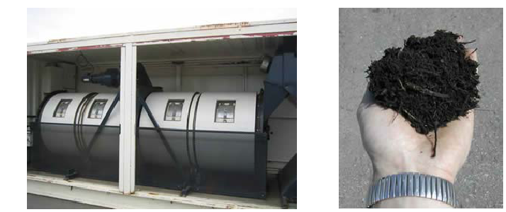

It is reported that the Rotocom unit trialled by CCC proved to be mechanically reliable, simple to operate, and was not prone to waste compaction or balling. A 1:1 mix of putrescible waste and shredded greenwaste was well composted after a 10-day in-vessel composting phase.

Three local contractors, who have established good performance records, will be invited to bid for the site works, which will be a minor works contract. These minor works will be well within the capability of local contractors.

The services for greenwaste shredding, compost screening, transport, compost site operating labour will be obtained through limited competitive tender from firms such as Streetsmart. These firms are already performing similar tasks for the Council.

The Council staff and council’s consultants will coordinate, supervise and manage the contracts.

The only potential constraint is the resource consenting process. However, with the odour management method proposed by Rotocom, our proposed site management, the strategic selection of the sites, and the proposed Tairua trial to demonstrate good operating practices, we are confident that EW will grant the consents.

11. Implementation

The implementation of the proposed Tairua in-vessel composting trial will ideally be undertaken over the upcoming summer months (November 2007 through to April 2007). Thereafter, permanent composting plants are proposed to be implemented in the next two financial years, at Whangamata, Tairua-Pauanui and Whitianga.

The project management will be jointly undertaken by the Council staff and consultant.

